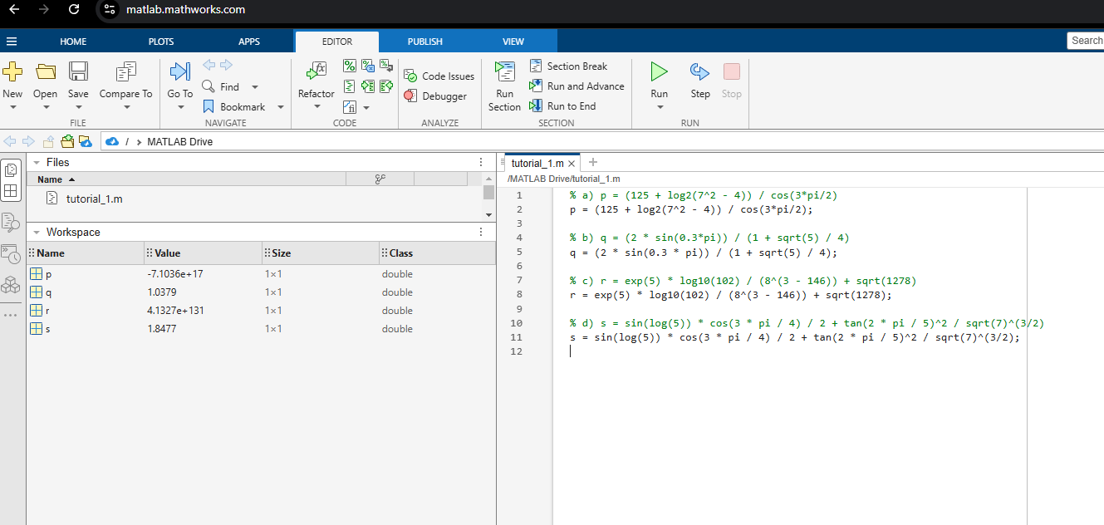
01)



02)
a)
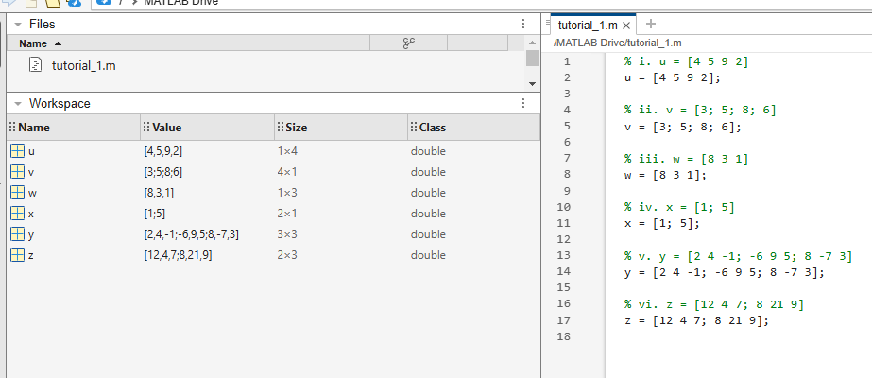



02)
b)

i. u + x (error, dimensions don't match)
u and x cannot be added as they have different dimensions

ii. u - v' (valid)
result_ii = u - v';

iii. u * v (error, dimensions don't match)
u and v cannot be multiplied as their dimensions are incompatible for matrix multiplication

iv. u .* v (valid element-wise multiplication)
result_iv = u .* v';

v. v * x (valid matrix multiplication)
result_v = v * x;

vi. x' + v (valid matrix addition)
result_vi = x' + v';

vii. x ./ y (error, dimensions don't match)
x and y cannot be divided element-wise as they have incompatible dimensions

viii. x / y (error, dimensions don't match)
x and y cannot be divided as they are incompatible dimensions for matrix division

03)
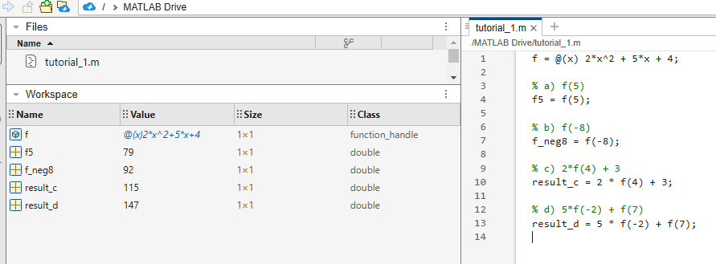



04)
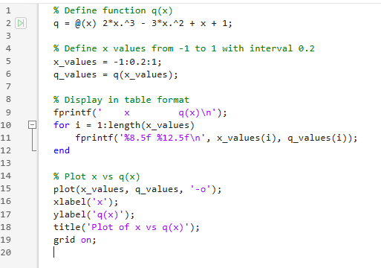

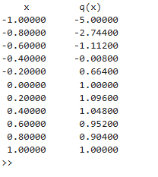
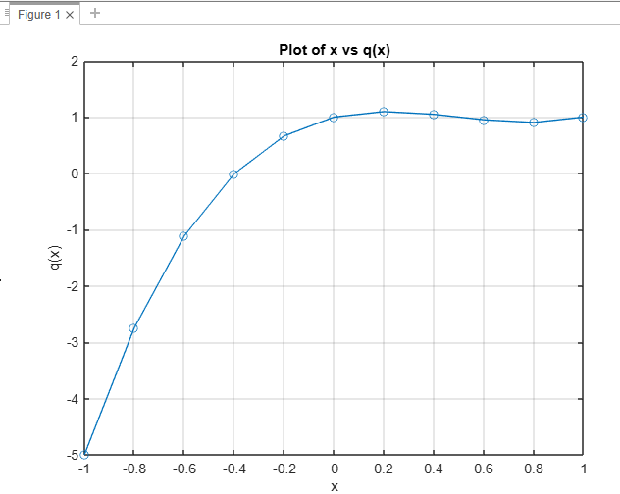
05)
